After designing the transformer, we have constructed forward converter model in MATLAB/Simulink to verify our calculations and to findout the stresses on the components. Since we couldn’t realize our transformer design, we couldn’t measure the transformer parameters such as leakage inductance. Therefore, we firstly simulated the converter with ideal transformer and ideal components. Simulink model of the converter is seen in Figure X.

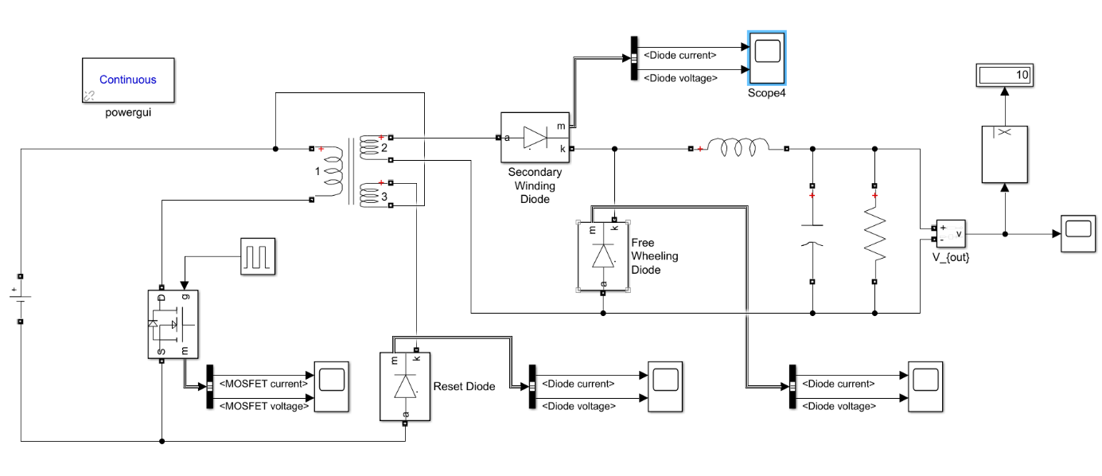

Figure X. Simulink model of the forward converter

Output voltage characteristics are given in Figure X and X for 24V and 48V input voltage respectively. When input voltage is 24V, 43.8% duty cycle results in the 10V output voltage with 0.9V voltage ripple. When input voltage increases to 48 V, required duty ratio decreases to 21.4% and output voltage ripple becomes 1.2V which fulfills the ripple requirement.

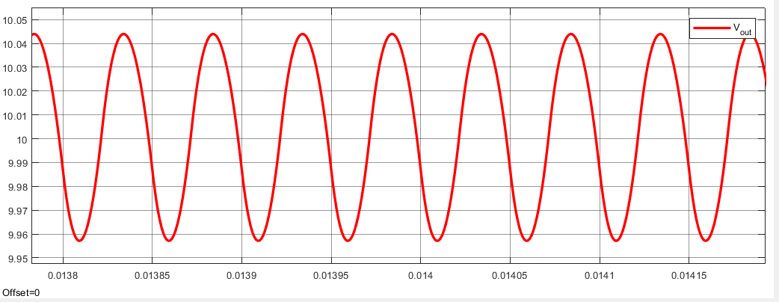

Figure X. Output voltage of the converter, Vi=24V

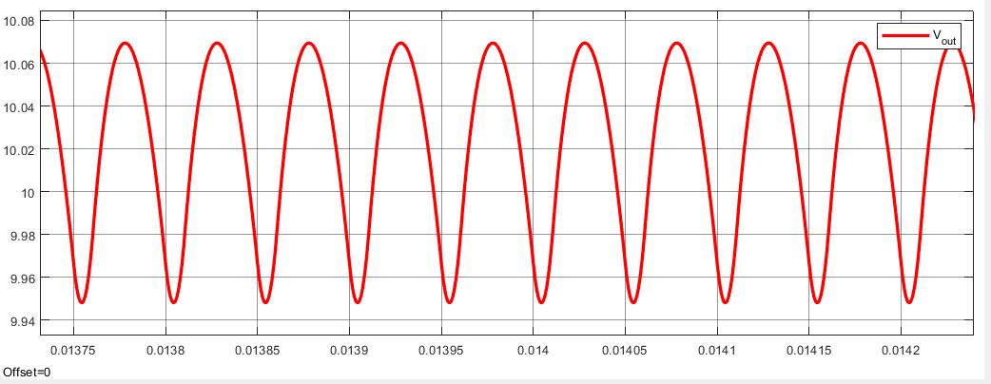

Figure X. Output voltage of the converter, Vi=48V

In Figure X and X, voltage and current waveforms of the MOSFET is given for two different input voltage level.

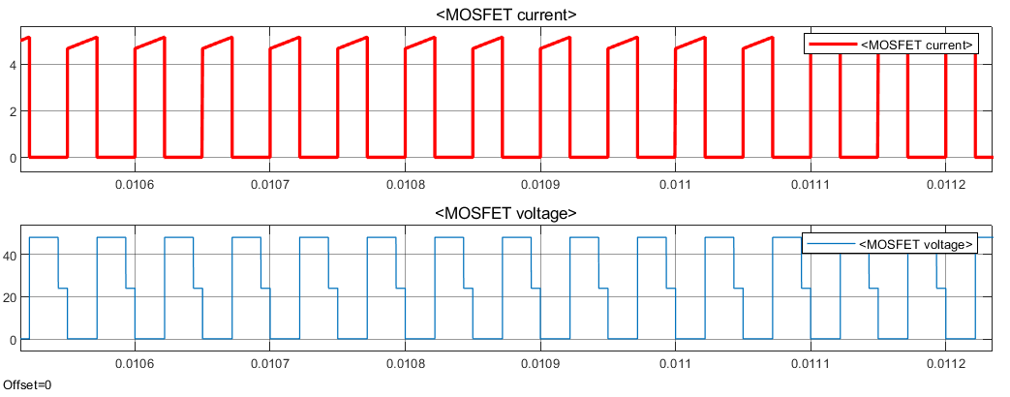

Figure X. Voltage and current waveforms of MOSFET, Vi=24V

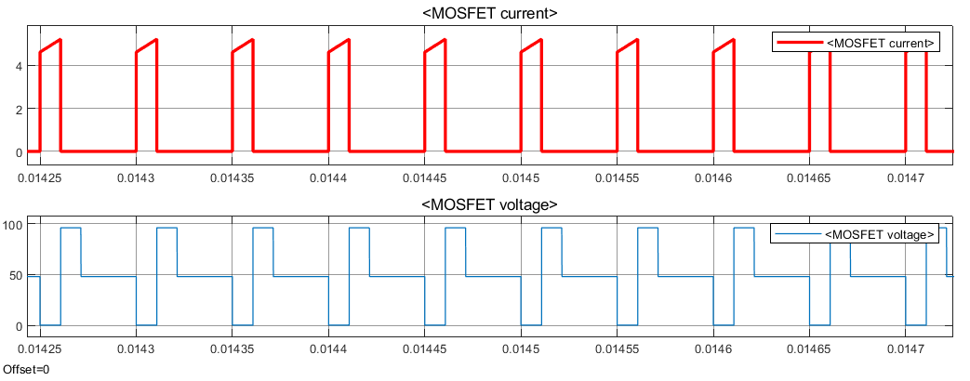

Figure X. Voltage and current waveforms of MOSFET, Vi=48V

Voltage and current waveforms of the diode which is series to reset winding is given in Figure X and X.

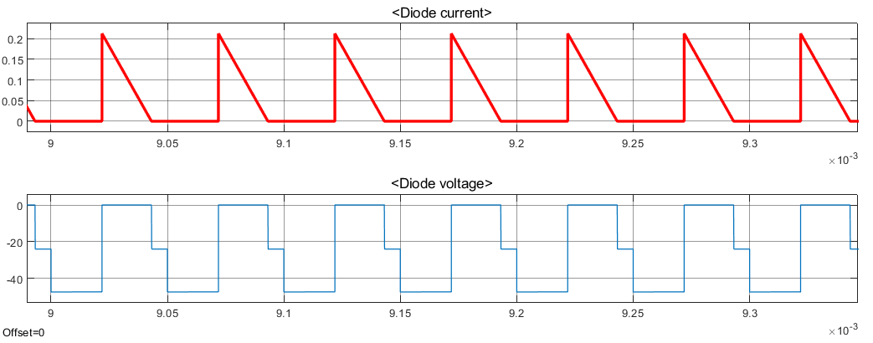

Figure X. Voltage and current waveforms of reset diode, Vi=24V

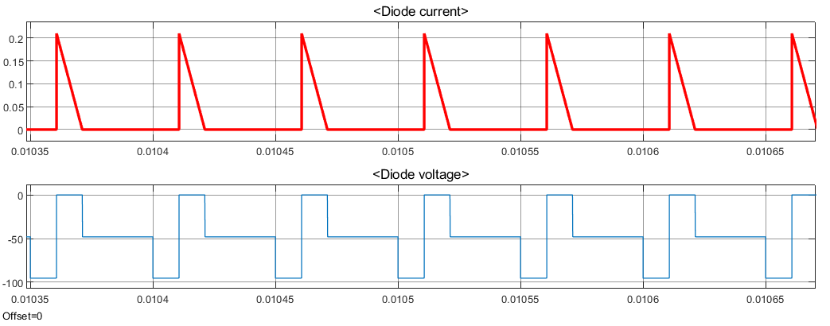

Figure X. Voltage and current waveforms of reset diode, Vi=48V

Below Figures X and X shows the waveforms of the diode which is placed at the secondary winding of the transformer.

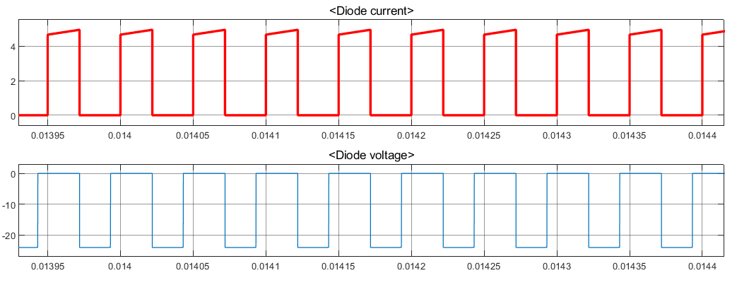

Figure X. Voltage and current waveforms of secondary diode, Vi=24V

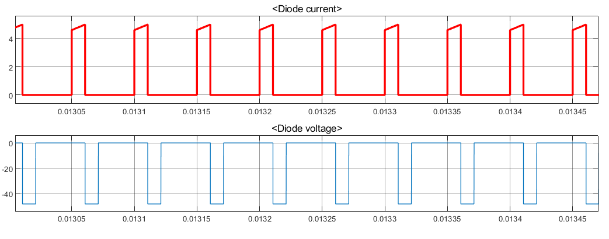

Figure X. Voltage and current waveforms of secondary diode, Vi=48V

Lastly, freewheeling diode current and voltage waveforms are given in Figure X and X.

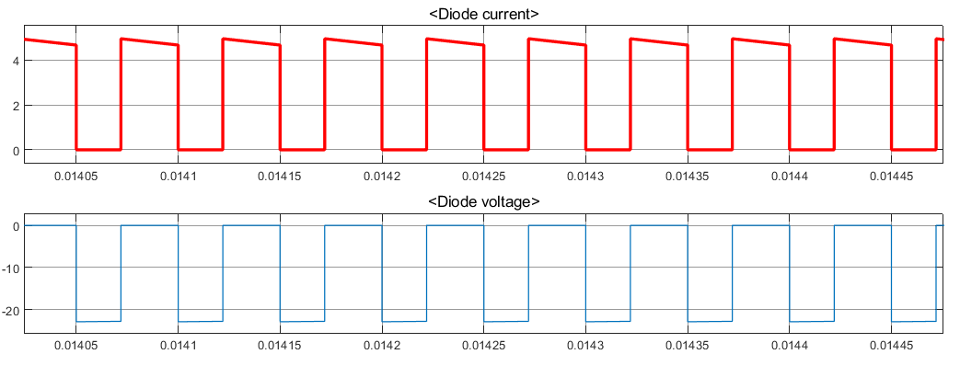

Figure X. Voltage and current waveforms of freewheeling diode, Vi=24V

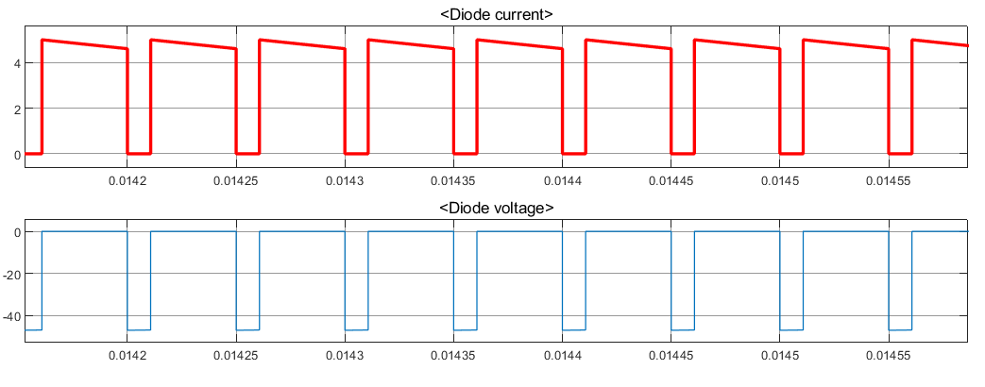

Figure X. Voltage and current waveforms of secondary diode, Vi=48V